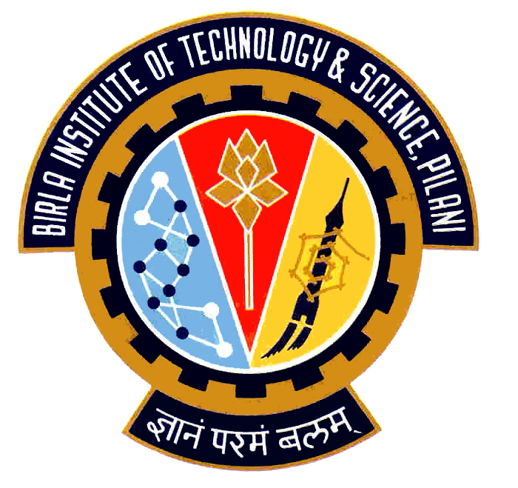

Election Commission

Birla Institute of Technology & Science – Pilani, Goa Campus, Zuarinagar, Goa-403726, INDIA
Tel: (0)98233 6368 Fax:0832-2557033

Final List of Candidates for Hostel Representatives:

AH 8

CULTURAL
S SRINIVASCHAKRAVARTHY P | 2006S3P4592
HOSTEL AND CAMPUS MANAGEMENT
VARUN G. M. | 2006P3PS187
KANCHAN KUMAR AGRAWAL | 2006P1PS442
MESS
P. V. SURESH REDDY | 2006P3PS153
SPORTS
MADDIREDDY VIJAY BHASKAR REDDY | 2006P8PS223

Chief Warden CEC

